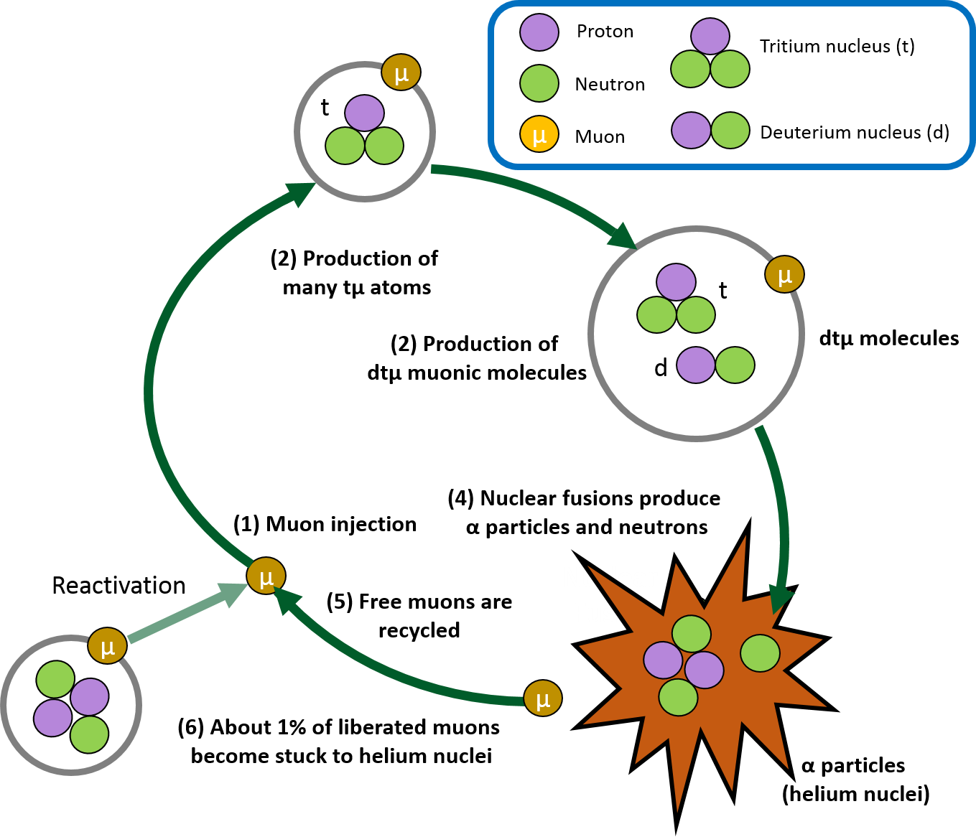
Copyright: Joshua Yoon, Stanford University, http://large.stanford.edu/courses/2016/ph241/yoon1/

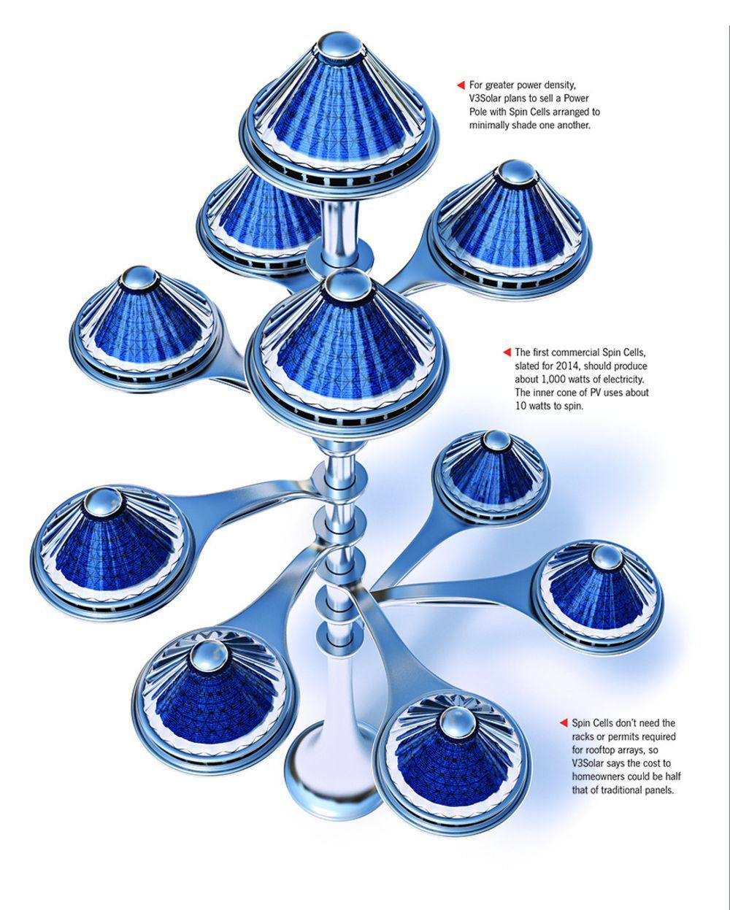
Solar Tree image created by Popular Science
Solar Power Pole with Spin Cells Image Credit: Graham Murdoch
V3 Solar
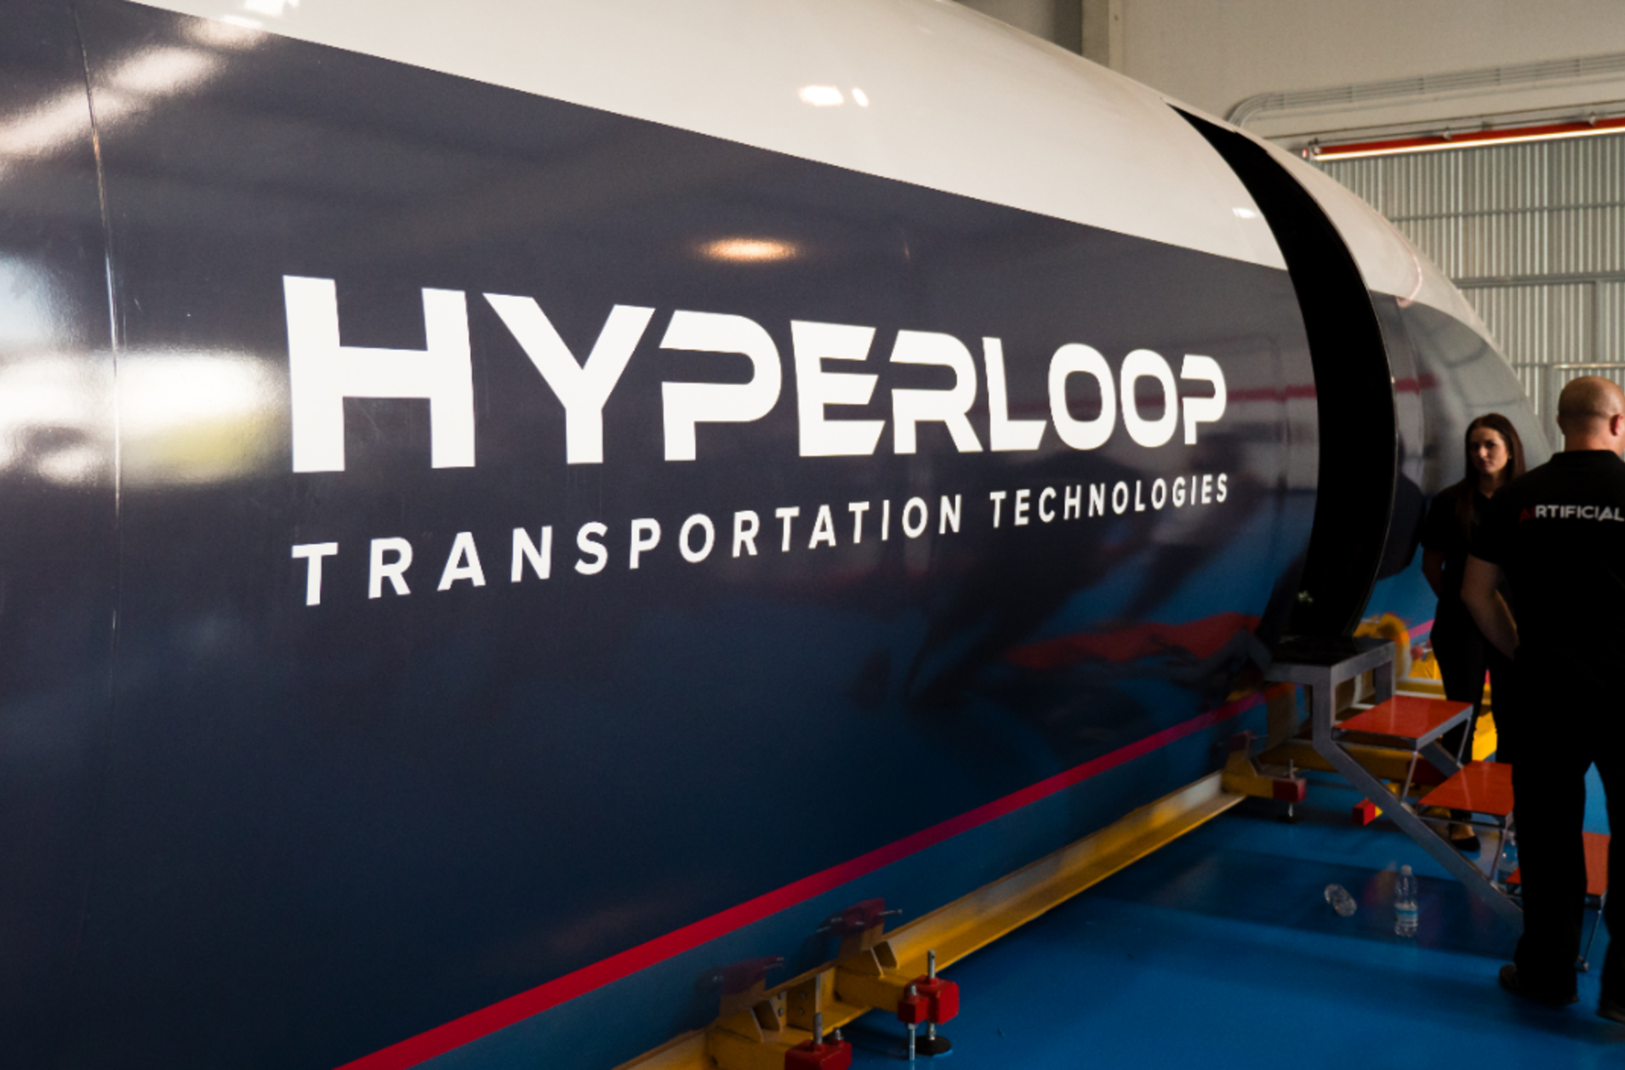

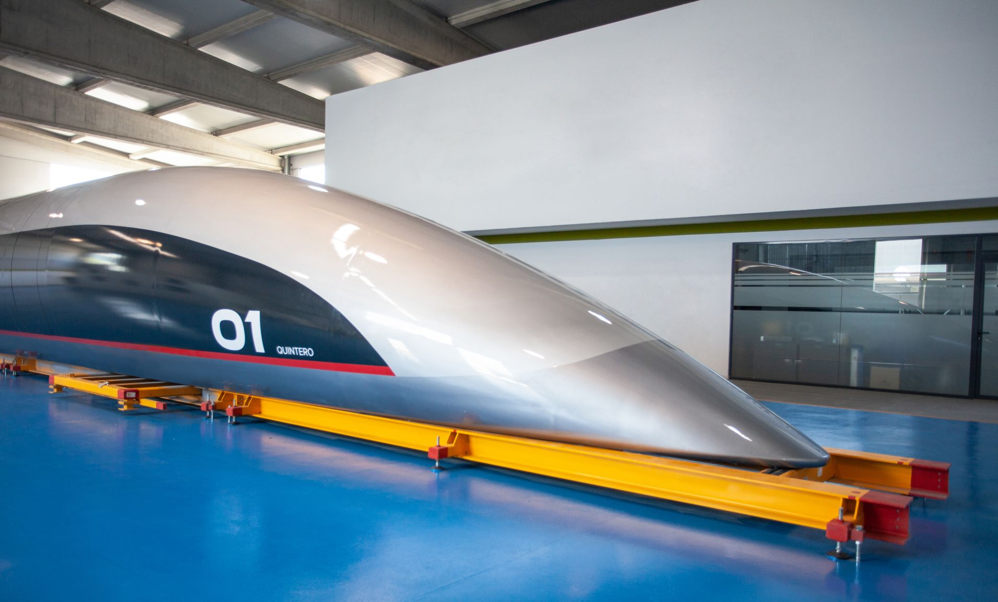
Copyright www.cnbc.com
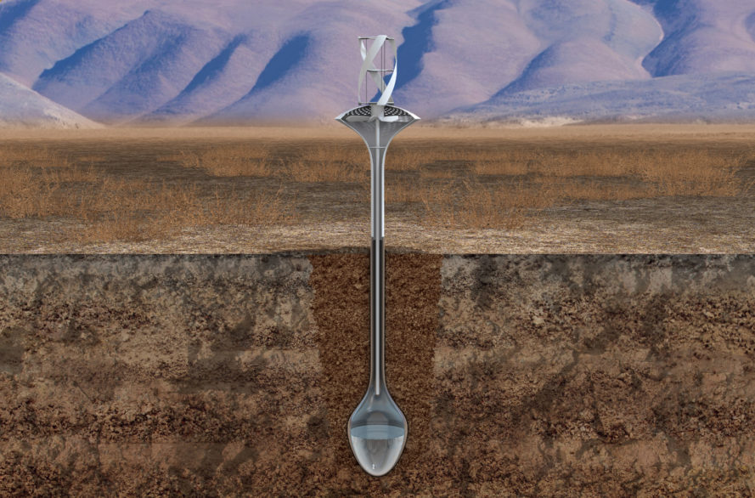
https://inhabitat.com/wind-powered-water-seer-produces-11-gallons-of-clean-drinking-water-from-the-air/

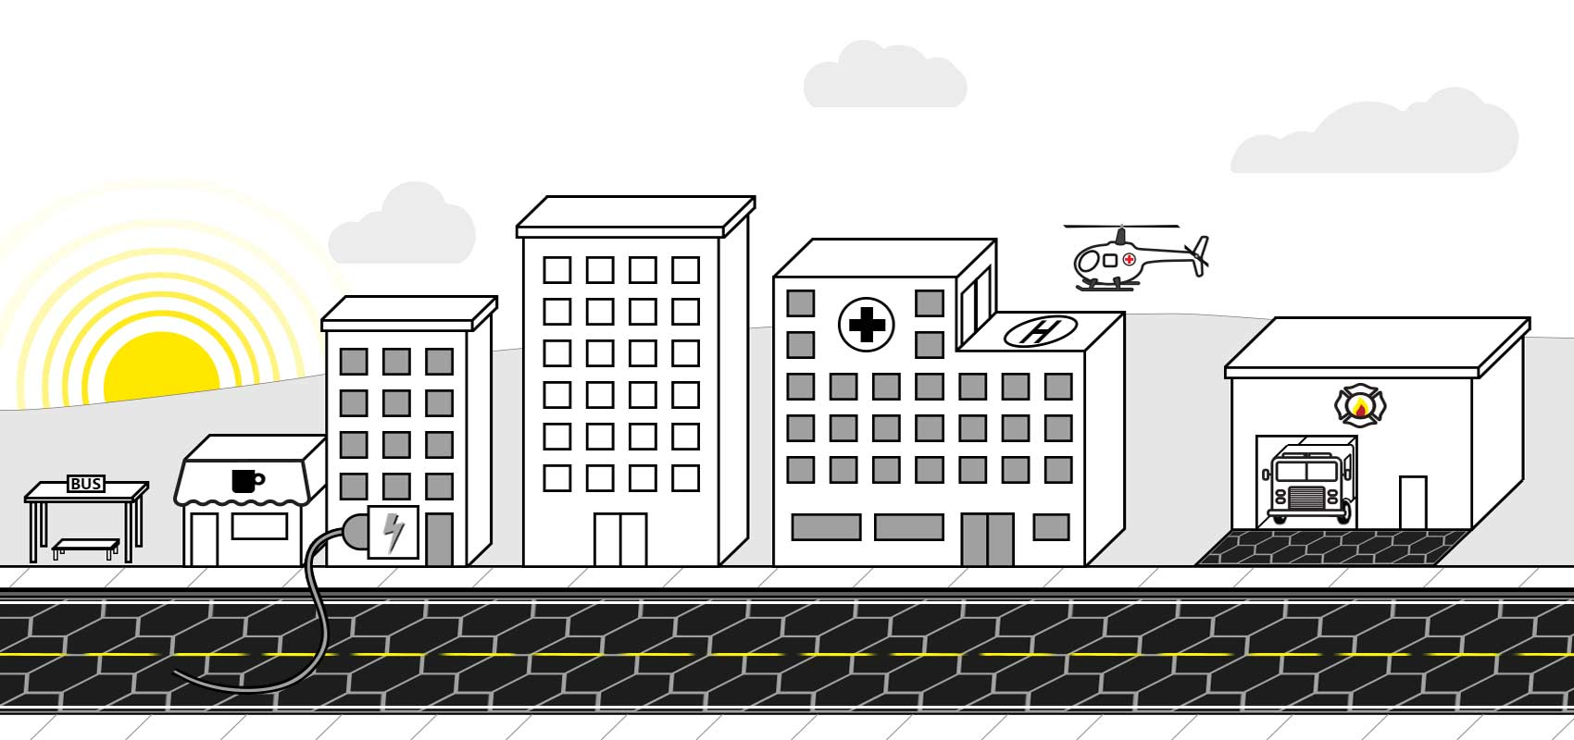
Copyright http://www.solarroadways.com/Product/Features

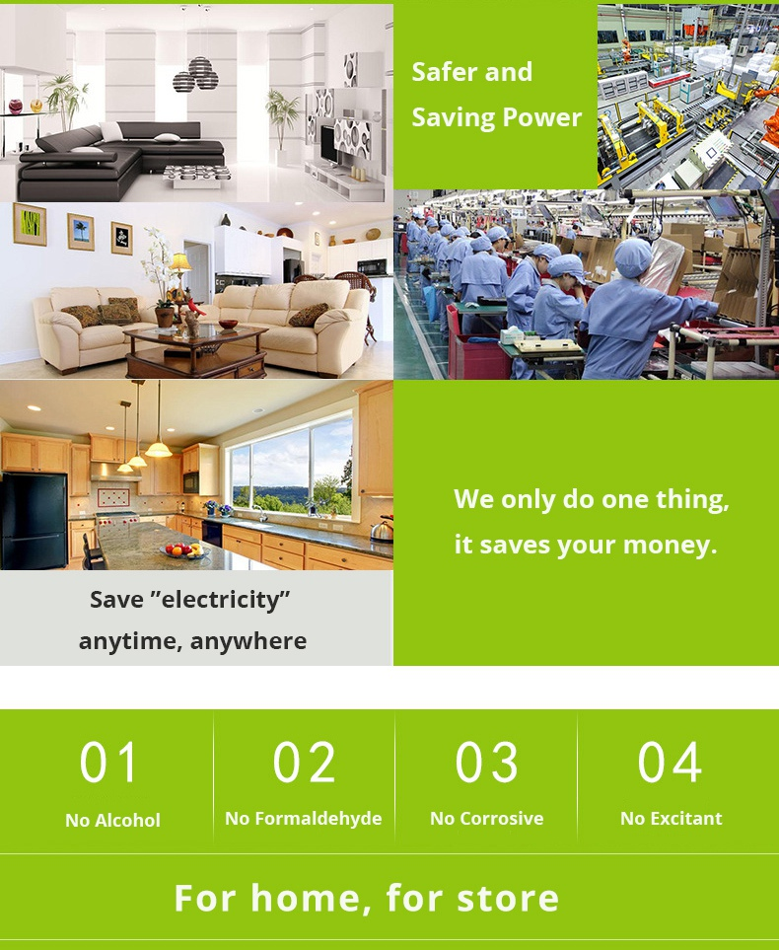
Copyright https://www.geekbuying.com/item/Home-Intelligent-Electricity-Saving-Box-White-402167.html
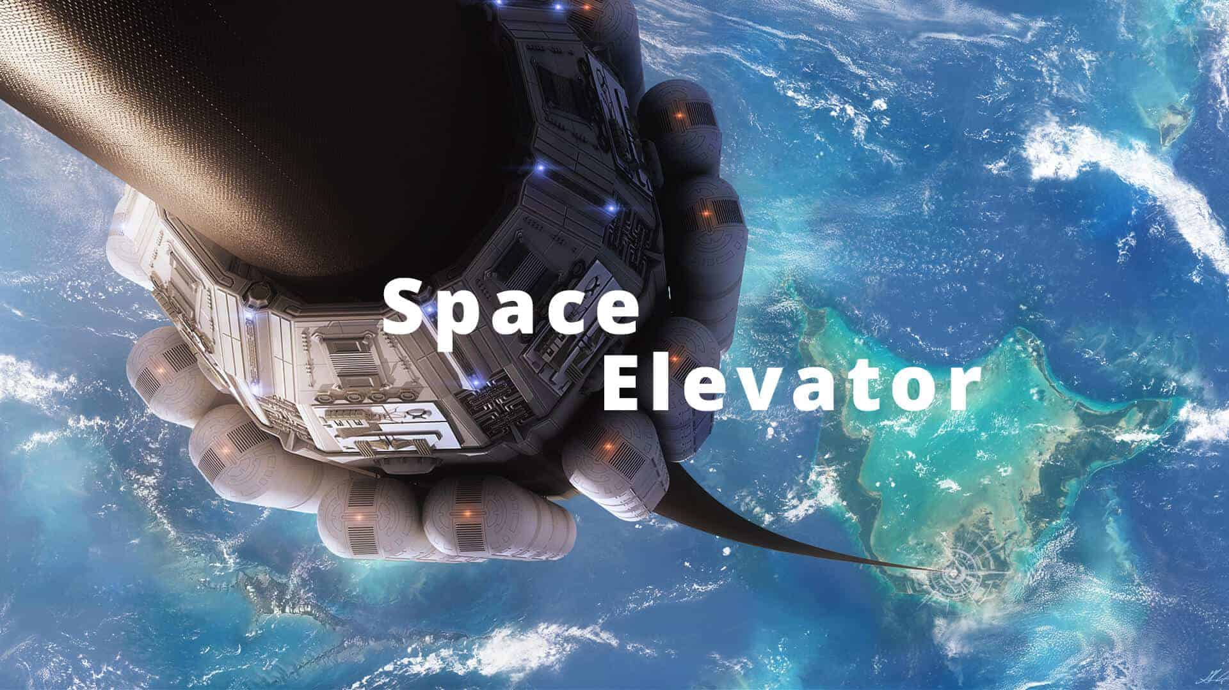
https://coolkidproblems.com/space-elevator/

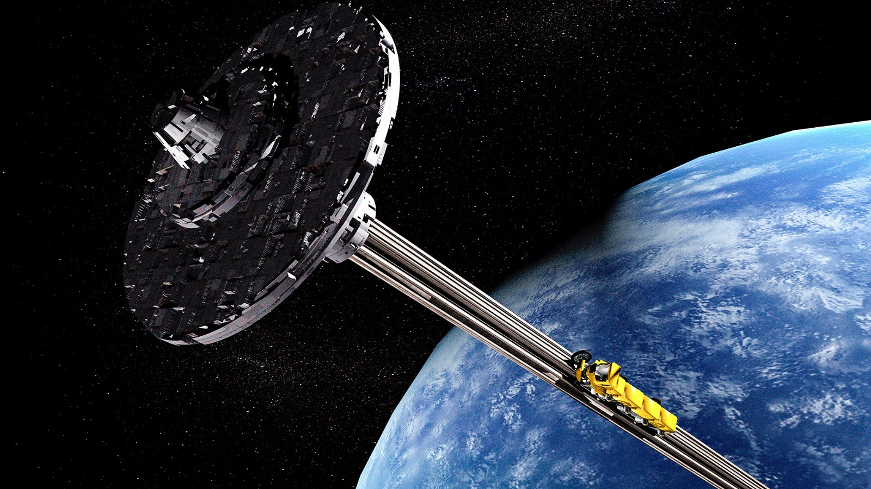
https://cdni.rbth.com/rbthmedia/images/2018.10/original/5bb7abfe85600a0963253126.jpg

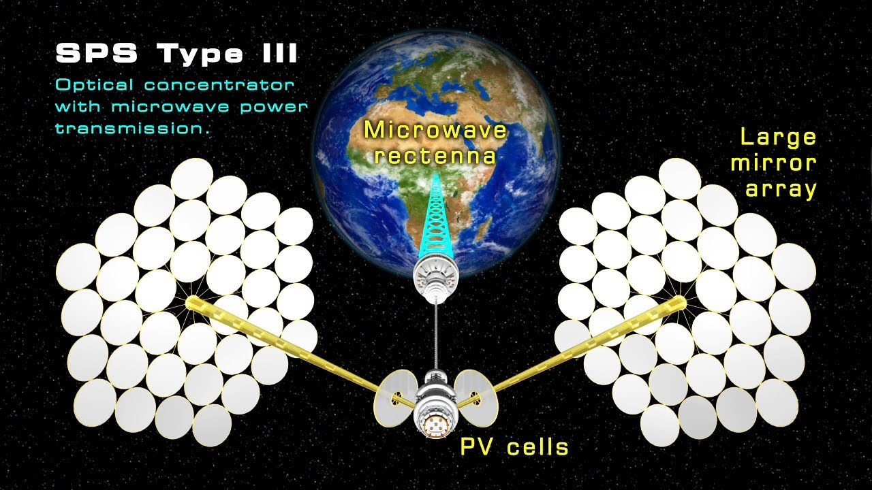
https://www.youtube.com/watch?v=vJcev0Jq3Ig

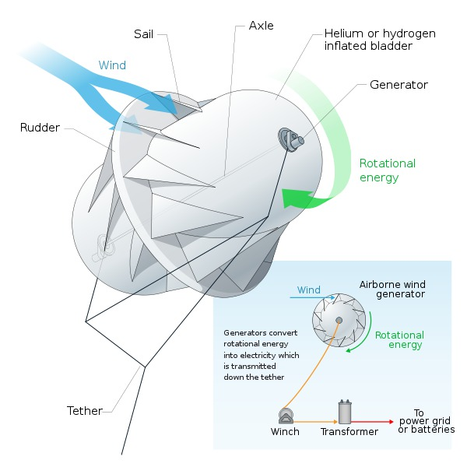 https://commons.wikimedia.org/wiki/File:Airborne_wind_generator-en.svg
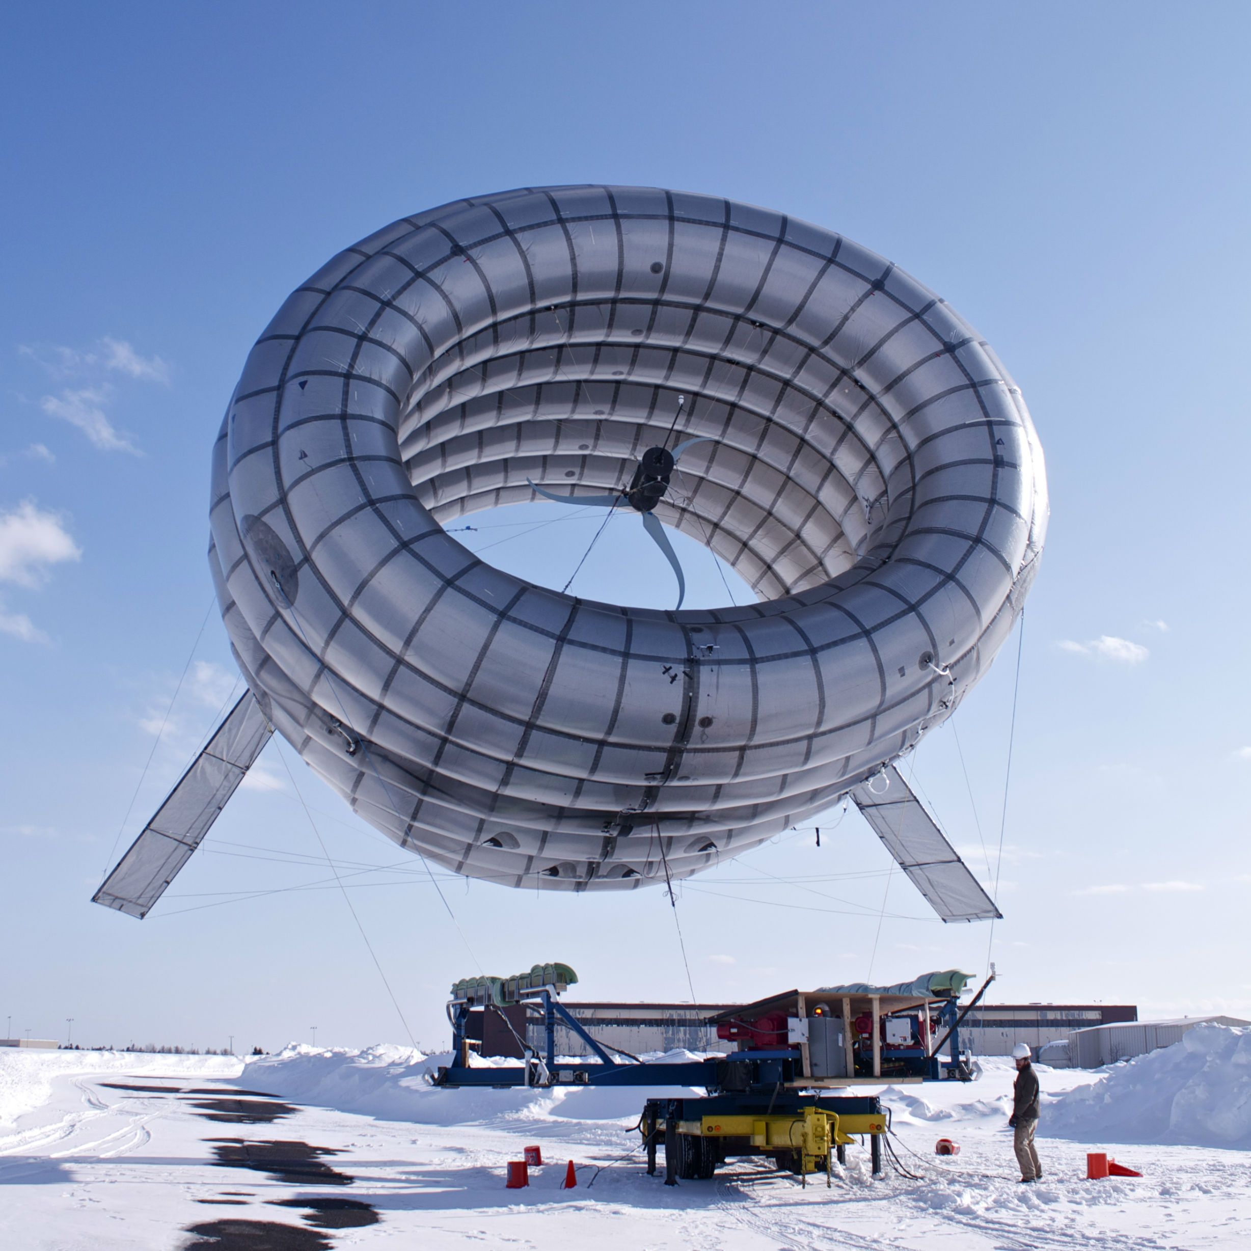
https://www.facebook.com/altaeros/

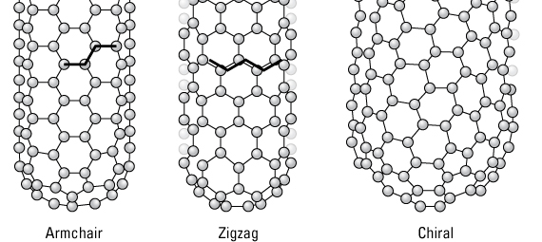
https://www.understandingnano.com/electrical-properties-carbon-nanotubes.html

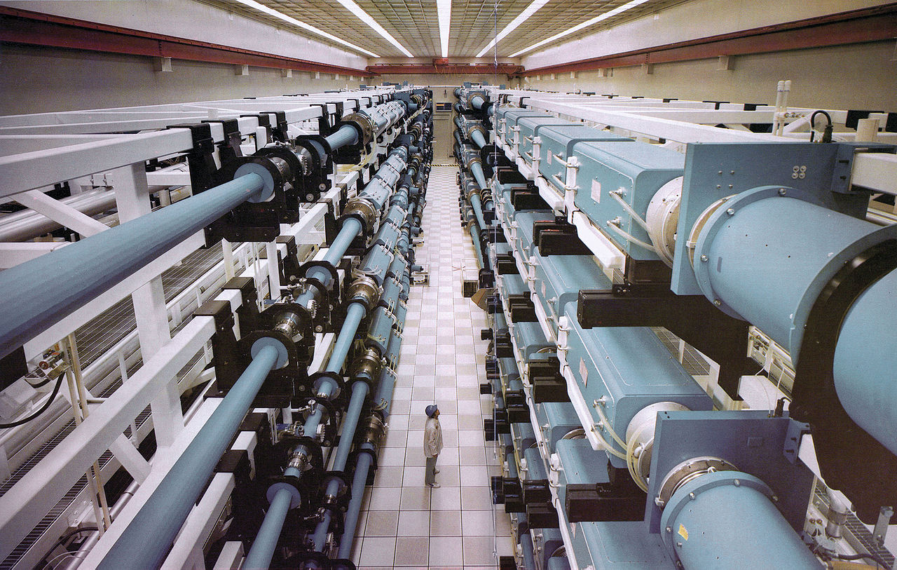
https://commons.wikimedia.org/wiki/File:NOVA_laser.jpg

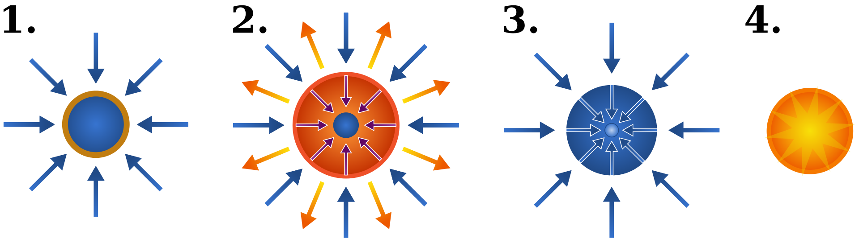
https://commons.wikimedia.org/wiki/File:Inertial_confinement_fusion.svg

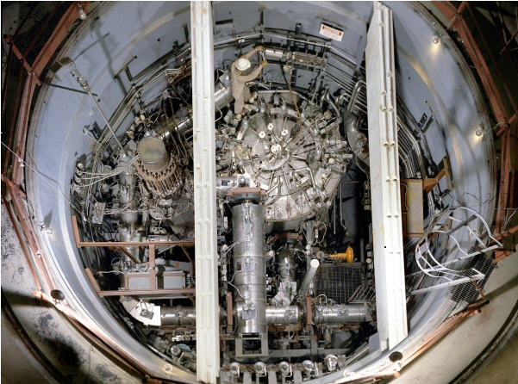
https://commons.wikimedia.org/wiki/File:Thorium_reactor_ORNL.jpg
https://en.wikipedia.org/wiki/Thorium-based_nuclear_power
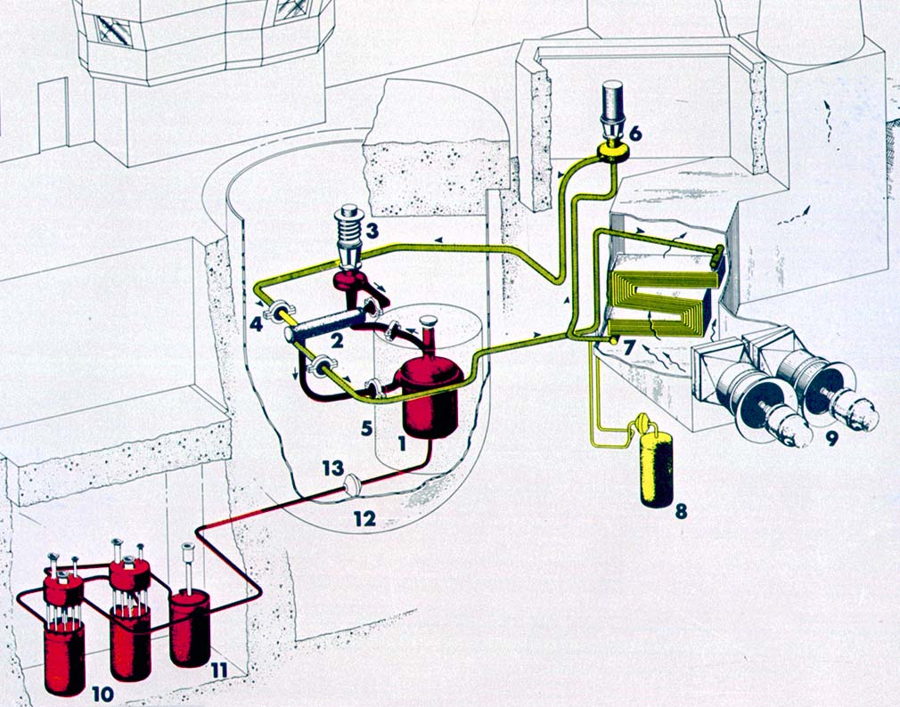
https://en.wikipedia.org/wiki/Molten-Salt_Reactor_Experiment, https://commons.wikimedia.org/wiki/File:MSRE_Diagram.png
(1) Reactor vessel, (2) Heat exchanger, (3) Fuel pump, (4) Freeze flange, (5) Thermal shield, (6) Coolant pump, (7) Radiator, (8) Coolant drain tank, (9) Fans, (10) Fuel drain tanks, (11) Flush tank, (12) Containment vessel, (13) Freeze valve.
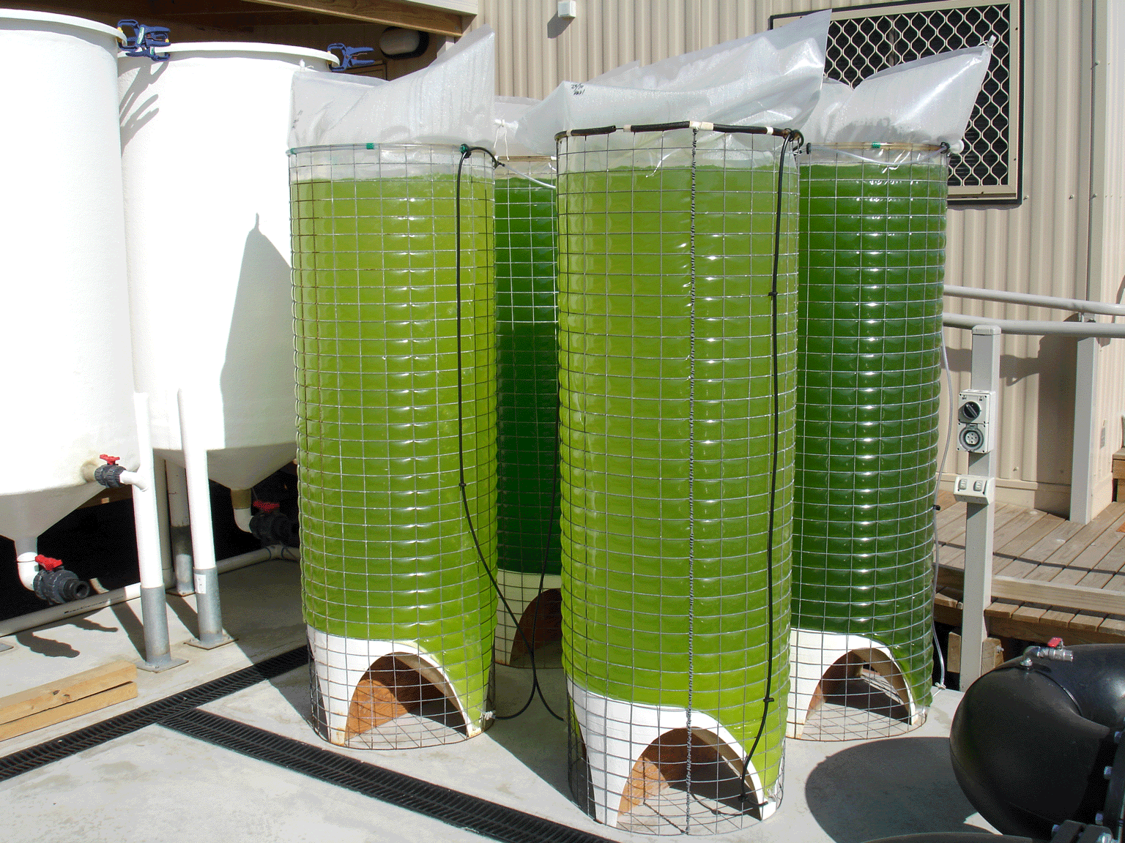
https://i.pinimg.com/originals/db/17/40/db17407793c6f34be3f4ef214bfcf125.gif
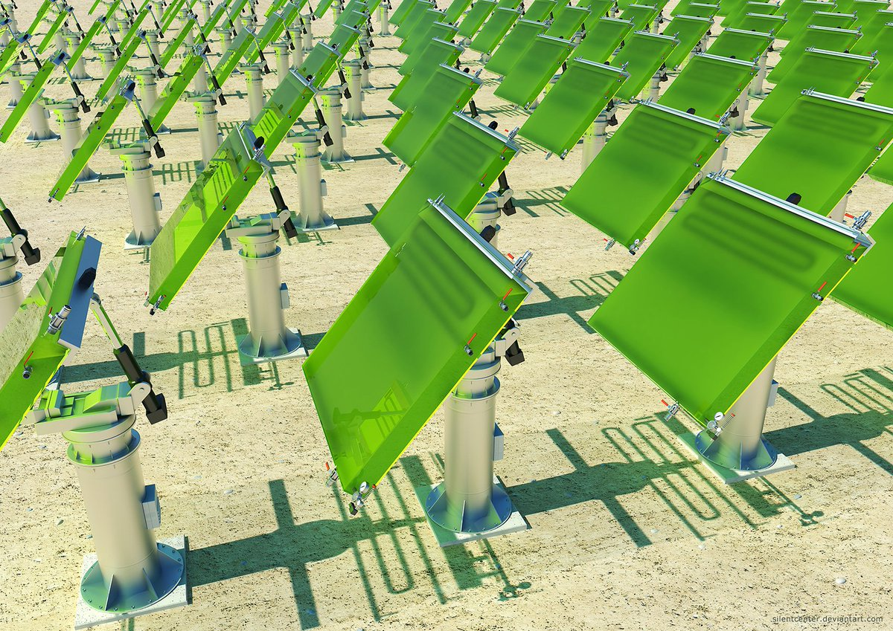
http://2016.igem.org/Team:Leiden/Bioreactor
http://pre01.deviantart.net/28ff/th/pre/f/2012/123/a/7/photobioreactors_by_silentcenter-d4ydxjj.jpg

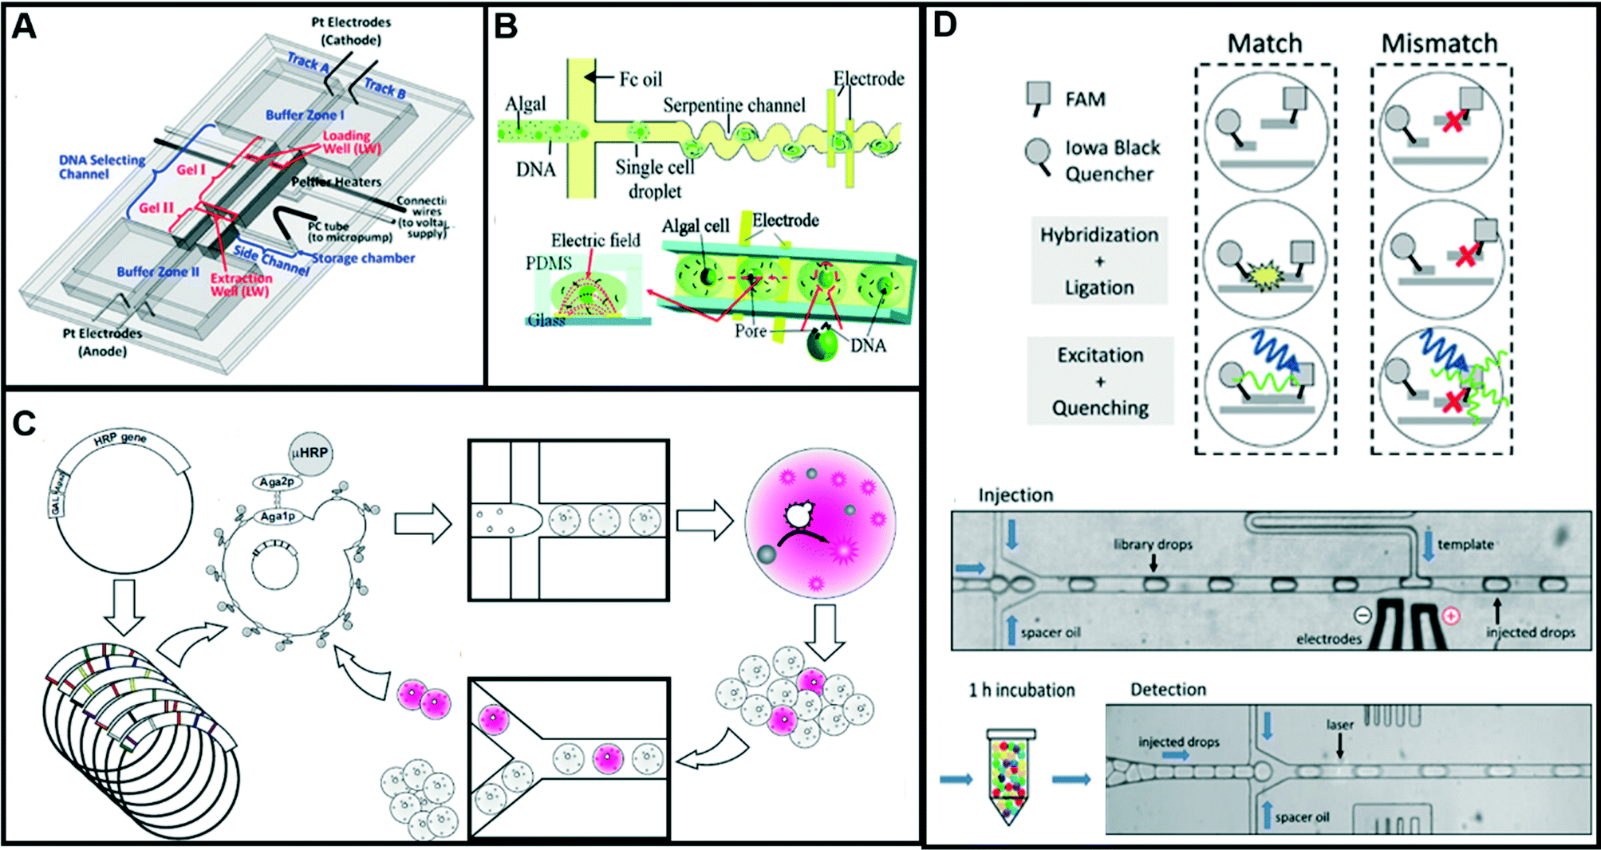
https://pubs.rsc.org/services/images/RSCpubs.ePlatform.Service.FreeContent.ImageService.svc/ImageService/Articleimage/2016/LC/c5lc01039j/c5lc01039j-f3_hi-res.gif

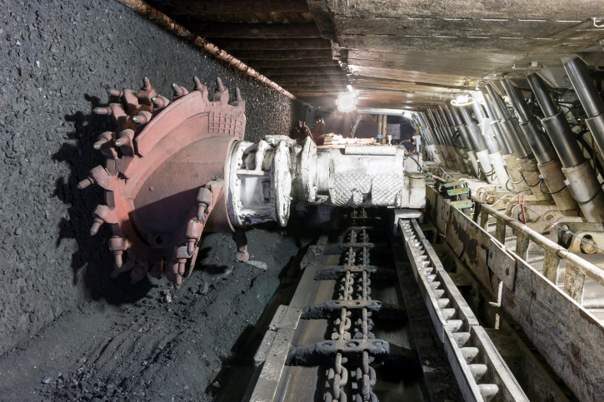
https://www.thermofisher.com/blog/mining/working-in-the-coal-minepart-2/
https://rigzonenews.wordpress.com/2015/02/25/horizontal-drilling-how-do-they-get-it-to-go-sideways/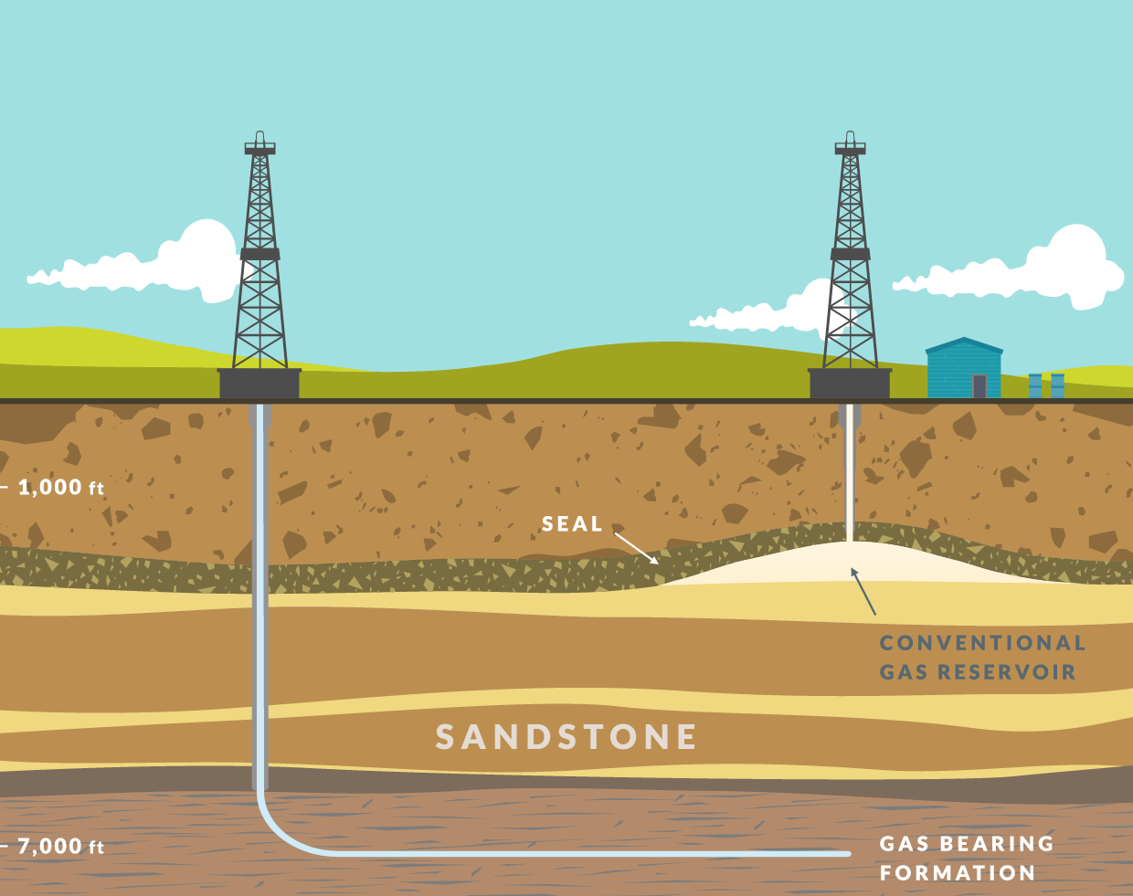
https://www.youtube.com/watch?v=mDBLsfOWEAo
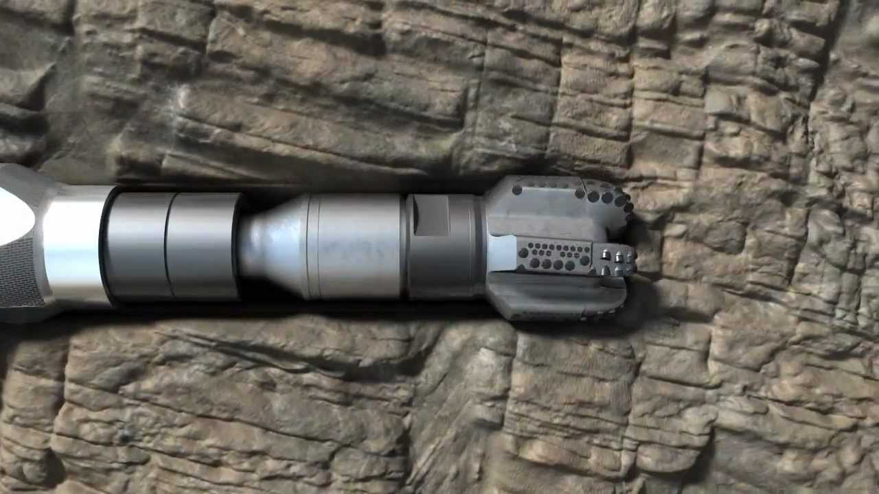
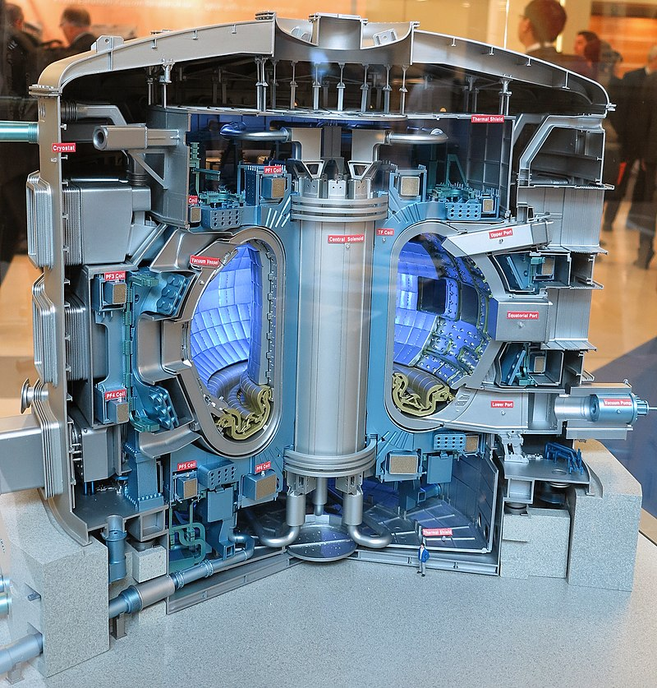
https://www.iter.org
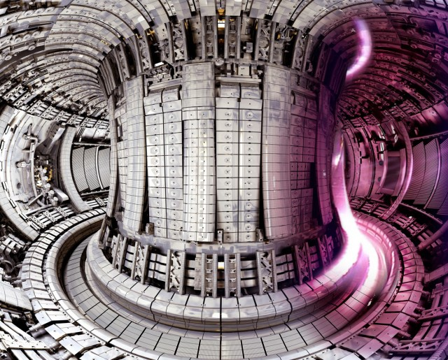
https://www.iter.org

https://www.iter.org
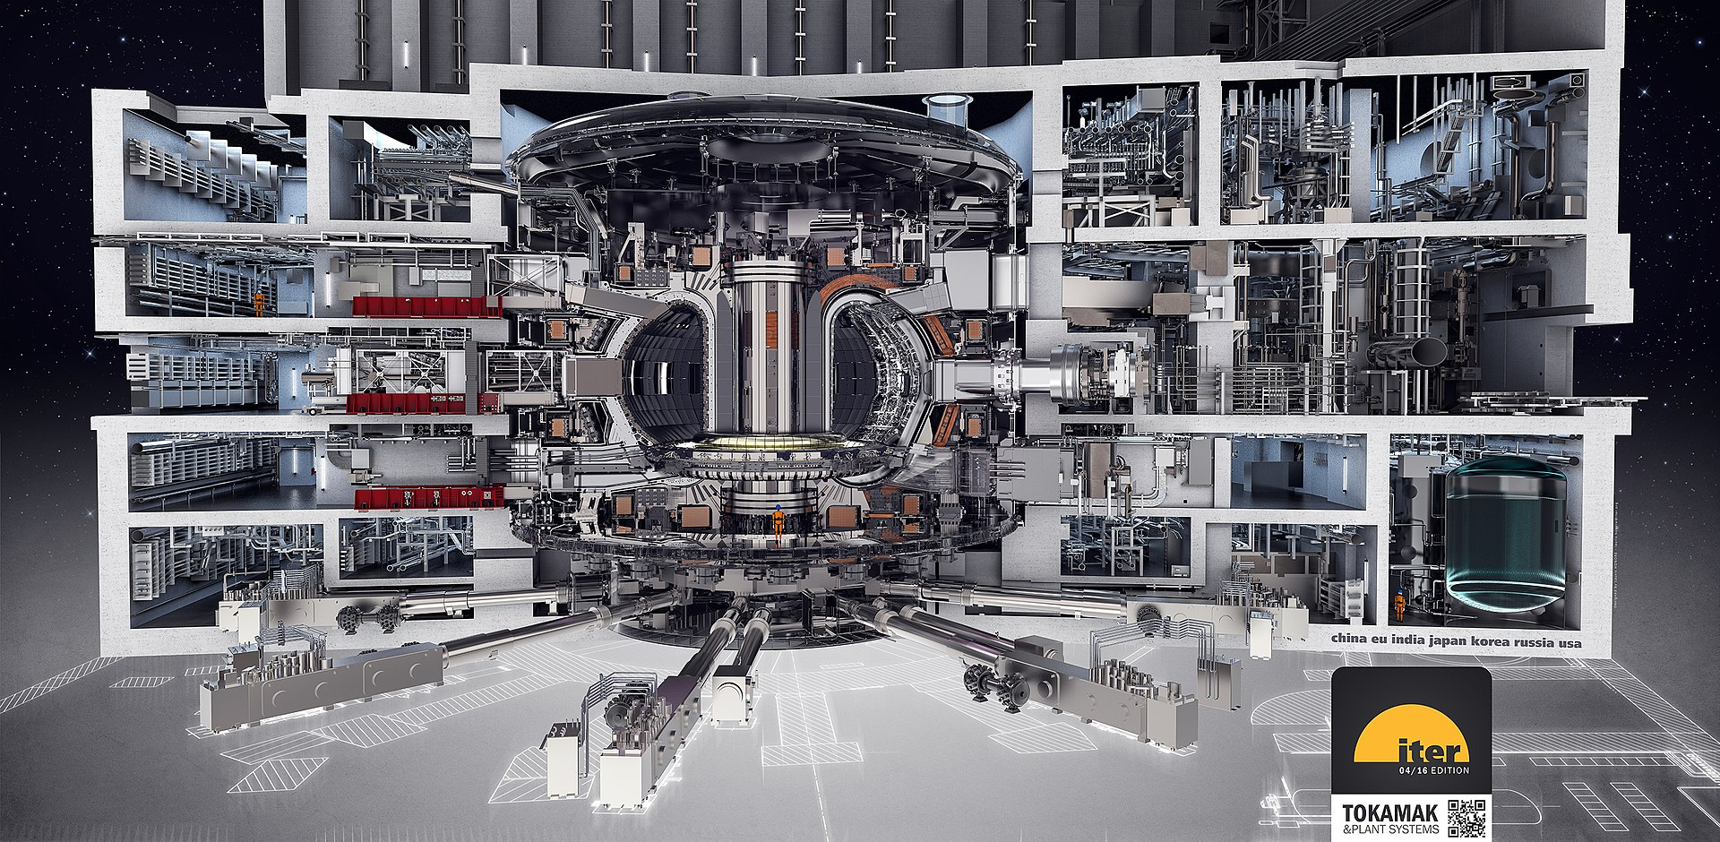
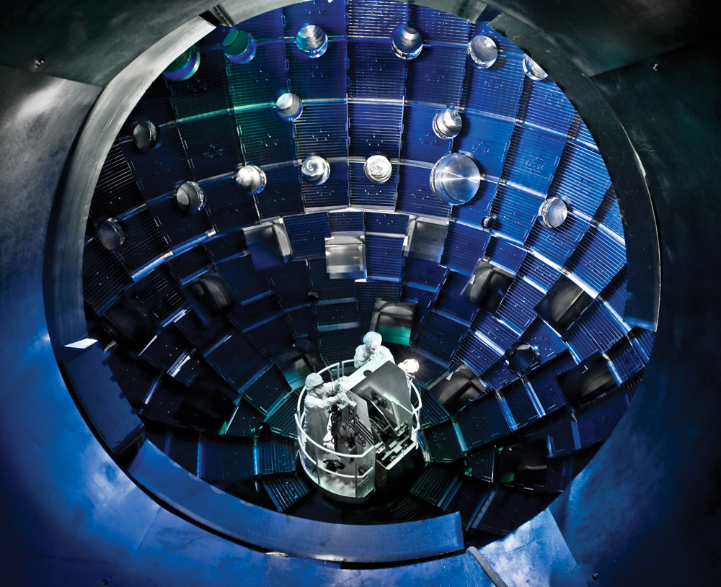
https://www.extremetech.com/extreme/101277-inside-californias-star-power-fusion-facility

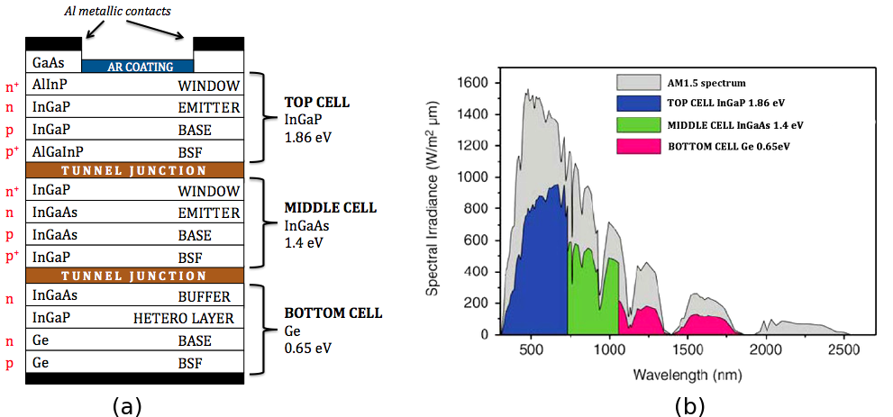
https://en.wikipedia.org/wiki/Multi-junction_solar_cell#/media/File:StructureMJetspectre.png
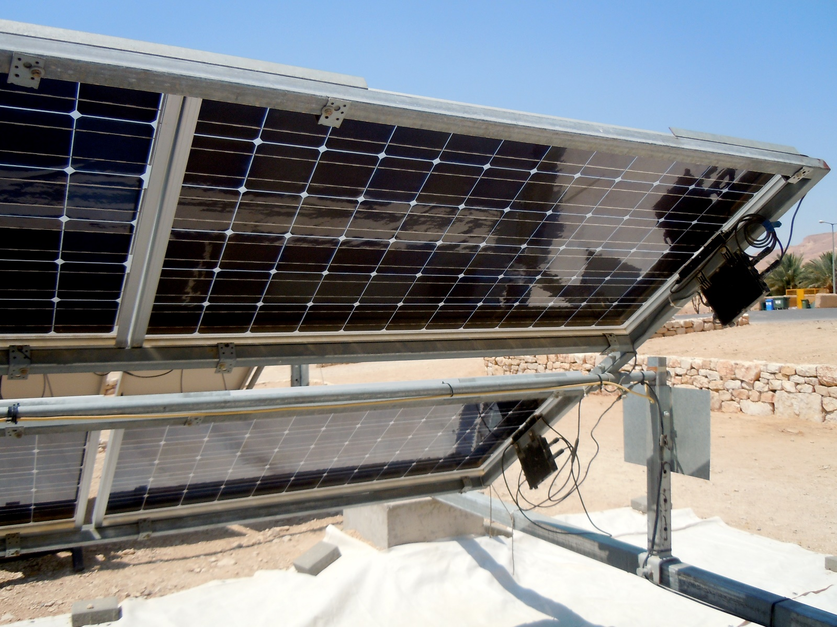
https://grecojl.wordpress.com/2011/07/18/desert-archaeology-sustainable-agriculture-carbon-free-energy-future-oh-my/
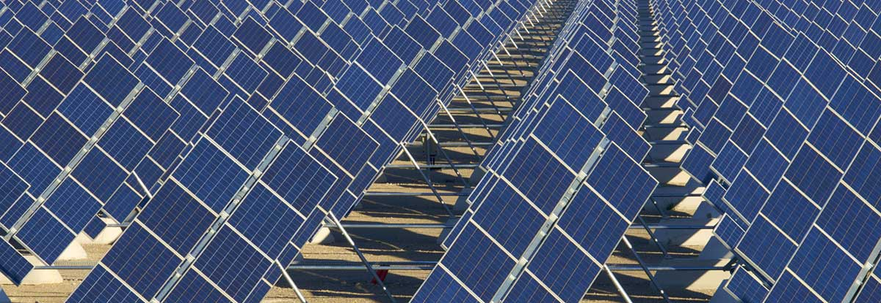
https://www.solarstrategia.com/en/news/useful-articles/two-sided-solar-panels-already-on-the-world-market

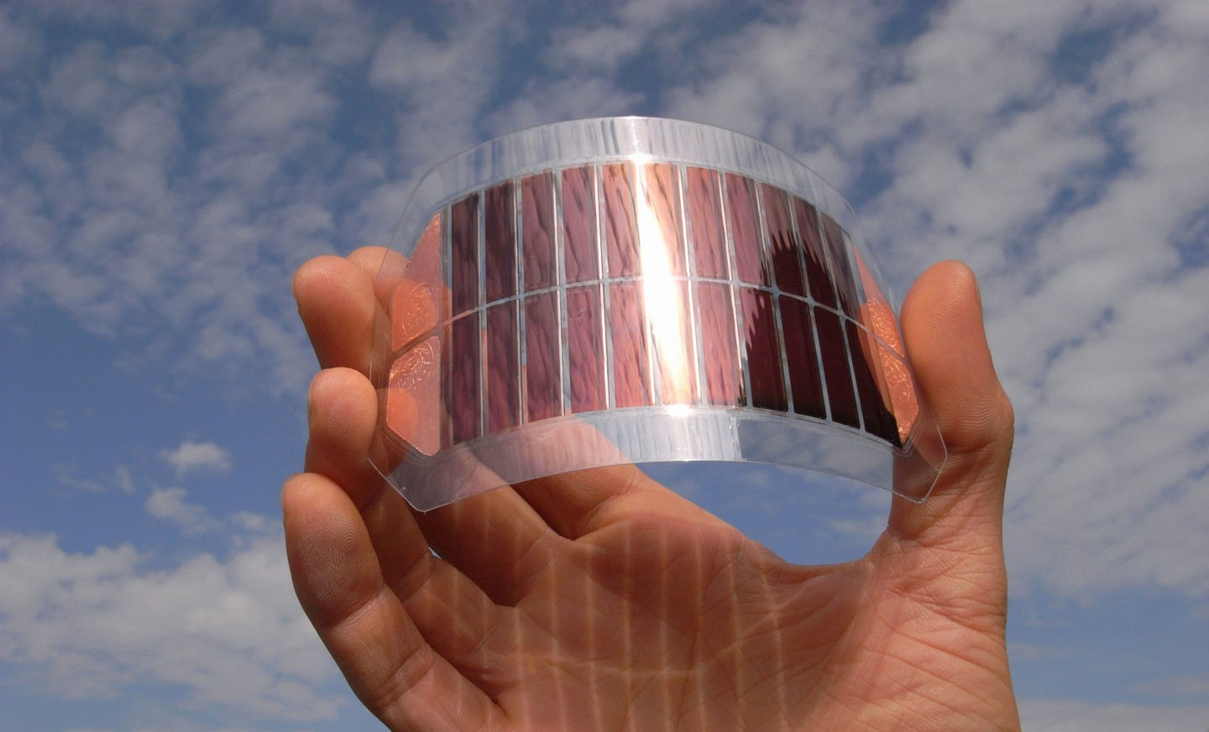
https://www.ise.fraunhofer.de/en/business-areas/photovoltaics/emerging-photovoltaic-technologies/organic-solar-cells.html

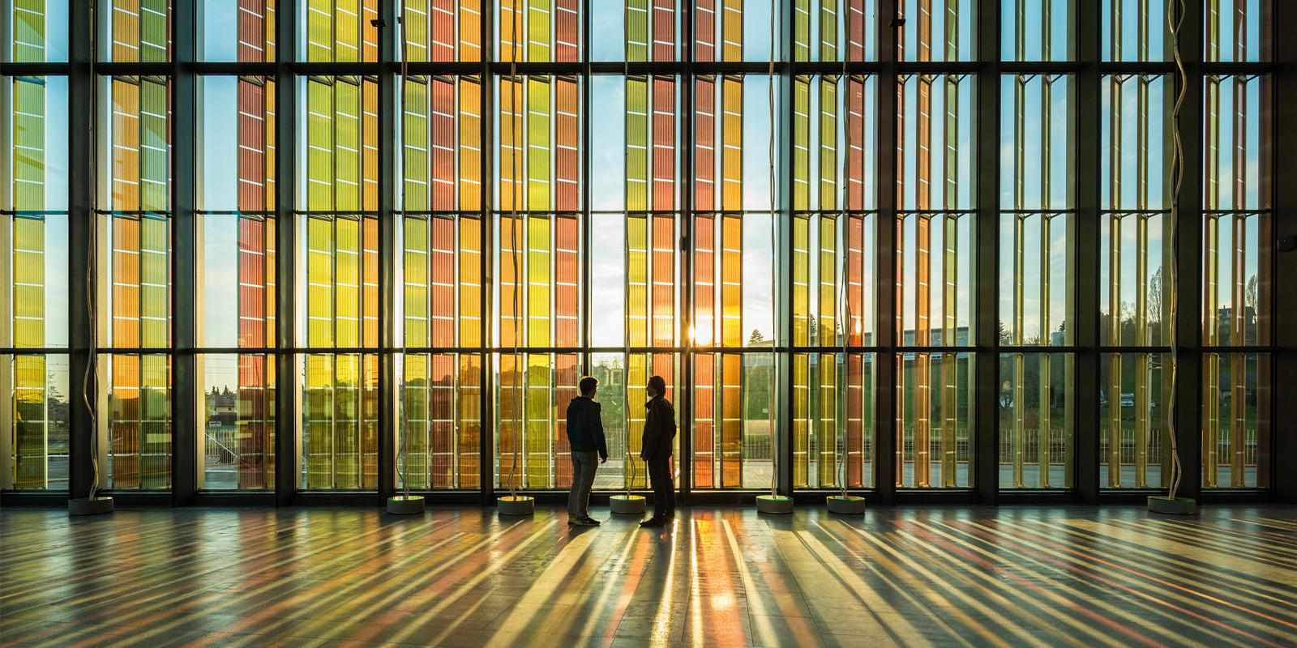
https://www.richterdahlrocha.com/en/project/swisstech_graetzel_epfl

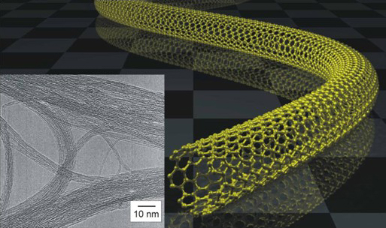
https://www.eikos.com/conductive-coatings.html
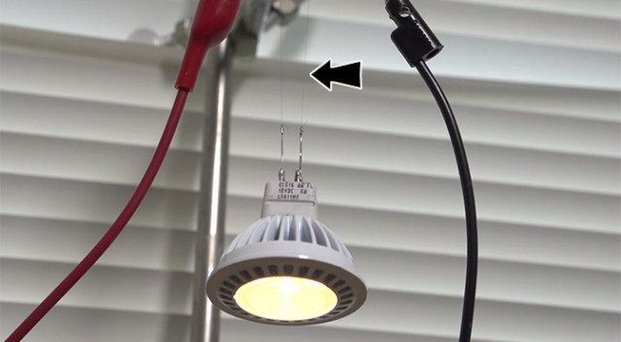
http://science.sciencemag.org/content/339/6116/182
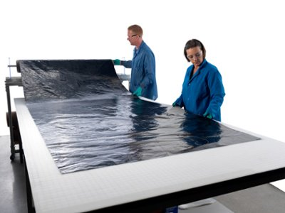 http://www.miralon.com/sheet/tape
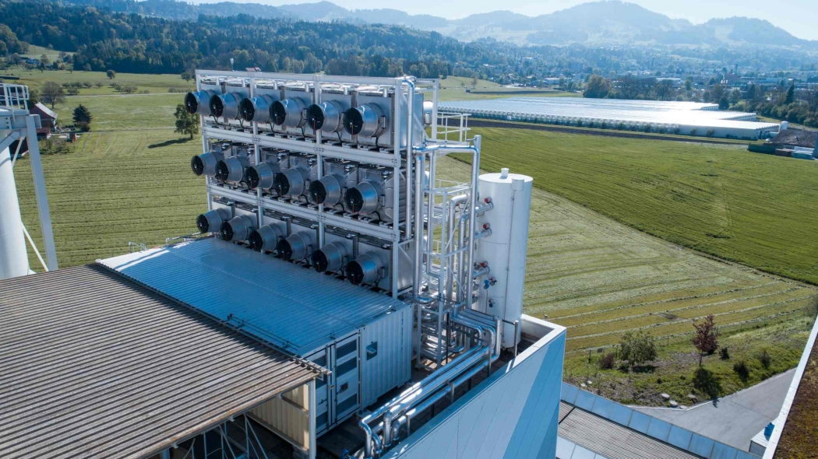
http://www.climeworks.com/

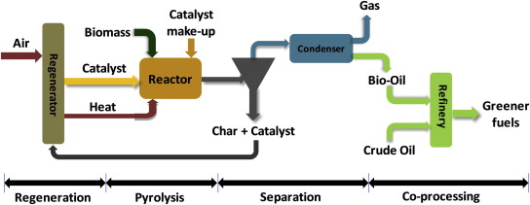
https://www.sciencedirect.com/science/article/pii/S0961953412004515

