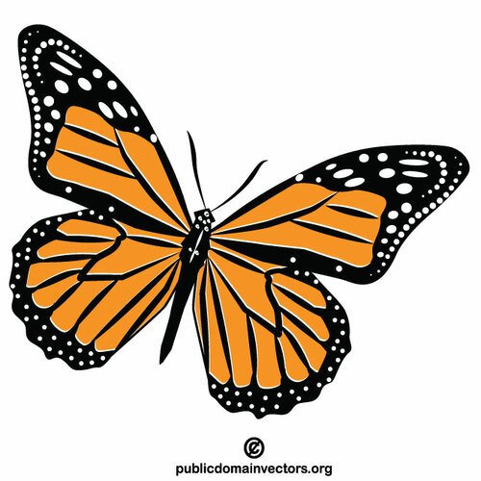
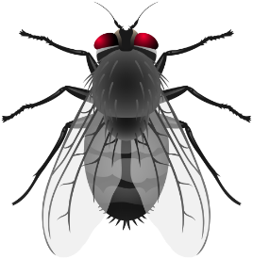
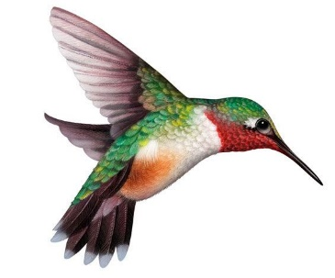
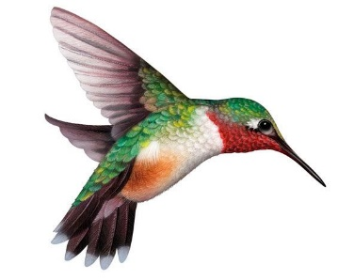
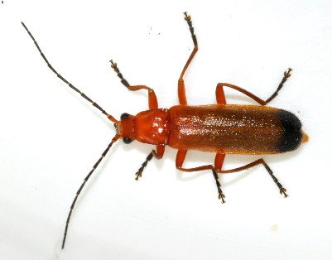
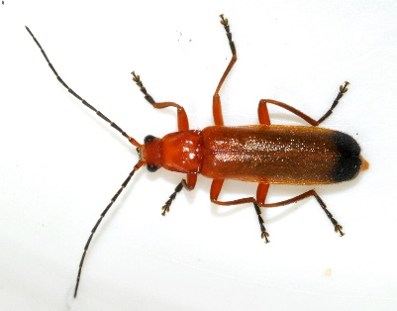
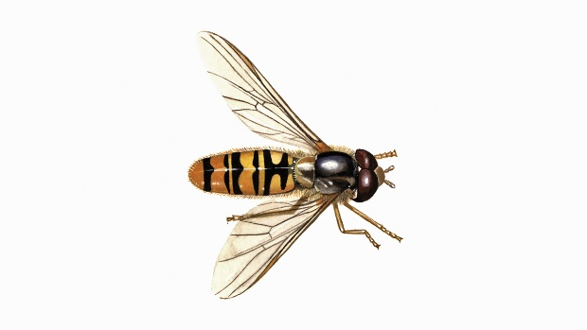
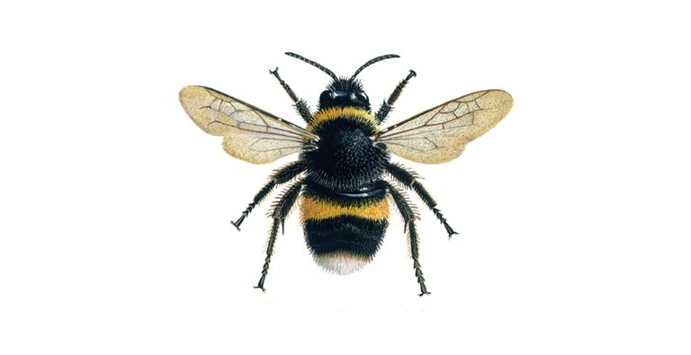

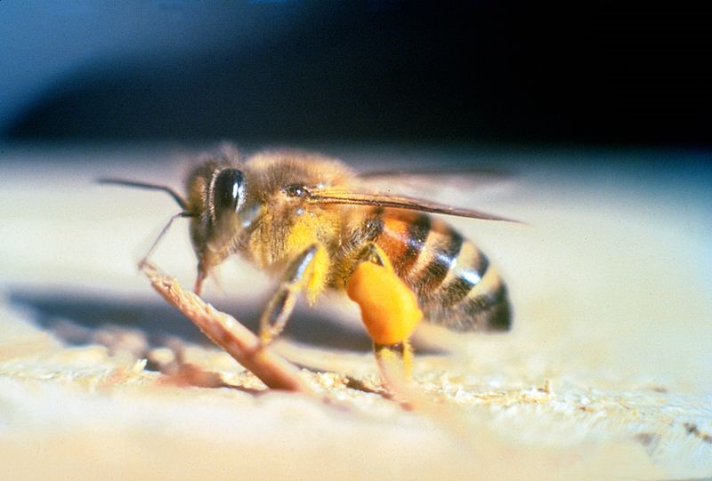

Zdroje obrázků:
- motýl: https://publicdomainvectors.org/cs/volnych-vektoru/Butterfly-hmyz-klipart/85761.html
- páteříček: https://commons.wikimedia.org/wiki/File:Rhagonycha-fulva-11-fws.jpg
- moucha: https://pics.clipartpng.com/midle/Fly_PNG_Clip_Art-2610.png
- pestřenka: https://www.rspb.org.uk/birds-and-wildlife/wildlife-guides/other-garden-wildlife/insects-and-other-invertebrates/flies/marmalade-hoverfly/
- čmelák: https://www.rspb.org.uk/birds-and-wildlife/wildlife-guides/other-garden-wildlife/insects-and-other-invertebrates/bees-wasps-ants/bumblebee/
- včela: https://commons.wikimedia.org/wiki/File:Apis_mellifera_scutellata.jpg
- kolibřík: https://cliparting.com/free-hummingbird-clipart-40607/

