
Rostliny 1. level
0
2
3
1-2

2
3
0
1-2

3
0
2
1-2

1-2


1
2
2
1-2

1-2
2
2
1
1-2

1-2
2
1
2
1-2

1-2
1-2


0
1
4

1-2
1-2

1
4
0

1-2
4
0
1 0
1-2


1-3
3
3
3
1-3

Rostliny 2. level

1-3
3
3
3
1-3

1-3
3
3
3
1-3

1-3

0
4
5
1-3

1-3
5
4
0
1-3

1-3
5
0
4
1-3

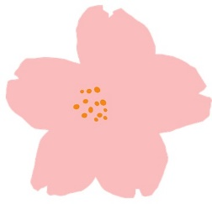
1-3
1-3
1
1
6
1-3

1-3
1-3
6
1
1
1-3

1-3
1-3
1
6
1
1-3



1-3
5
2
2
1-3

1-3

1-3
2
2
5
1-3

1-3

1-3
2
5
2
1-3

1-3

Rostliny 3. level


2-4
2-4
2-4
4
4
4
2-4


2-4
2-4
2-4
4
4
4
2-4


2-4
2-4
2-4
4
4
4
2-4

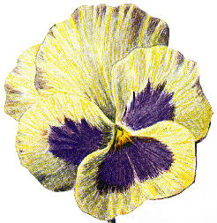
2-4
2-4
2-4
3
3
6
2-4

2-4
2-4
2-4
6
3
3
2-4

2-4
2-4
2-4
3
6
3
2-4

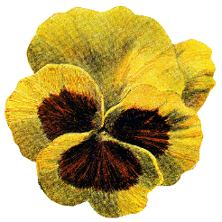
2-4
2
2
7
2-4

2-4

2-4

2-4
2
7
2
2-4

2-4

2-4

2-4
7
2
2
2-4

2-4

2-4

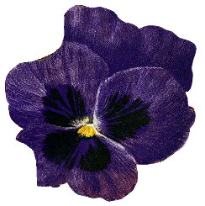
5
4
4
2-4

2-4
2-4
2-4

4
4
5
2-4

2-4
2-4
2-4

5
4
5
2-4

2-4
2-4
2-4

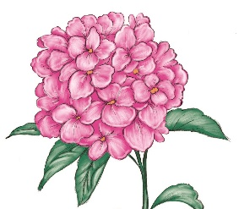
3
4
4
2-4

2-4
2-4
2-4

4
4
3
2-4

2-4
2-4
2-4

4
3
4
2-4

2-4
2-4
2-4


2-5
5
5
5
2-5

Rostliny 4. level

2-5

2-5
2-5
2-5

2-5
5
5
5
2-5

2-5

2-5
2-5
2-5

2-5
5
5
5
2-5

2-5

2-5
2-5
2-5


2
6
6
2-5

2-5

2-5
2-5
2-5
2-5

6
6
2
2-5

2-5

2-5
2-5
2-5
2-5

6
2
6
2-5

2-5

2-5
2-5
2-5
2-5

2-5
2-5
2-5

6
4
4
2-5

2-5

2-5

2-5
2-5
2-5
4
4
6
2-5

2-5

2-5

2-5
2-5
2-5
4
6
4
2-5

2-5

2-5

2-5
2-5

4
3
7
2-5

2-5



2-5

2-5

2-5
2-5
4
7
3
2-5

2-5

2-5

2-5

2-5
2-5
7
3
4
2-5

2-5

2-5

2-5

2-5

2-5
3
4
6
2-5

2-5

2-5

2-5
2-5
6
3
4
2-5

2-5

2-5

2-5
2-5
4
6
3
2-5

2-5

2-5

